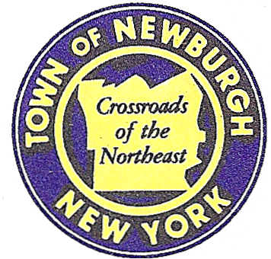

TOWN OF NEWBURGH
_______Crossroads of the Northeast __________________________
OLD TOWN HALL
308 GARDNERTOWN ROAD NEWBURGH, NEW YORK 12550

PLANNING BOARD
JOHN P. EWASUTYN, CHAIRMAN
TELEPHONE 845-564-7804
FAX 845-564-7802
E-MAIL: planningboard@townofnewburgh.org

PLANNING BOARD AGENDA

APRIL 16, 2015

*PLEASE NOTE: The Planning Board Meeting will start at 7:00 P.M. and all Applicants/Representatives
are to be present at that time. The Meeting will be held in the Meeting Room of Town Hall, located at
1496 Route 300, Newburgh NY.*

- T-Mobile Northeast LLC (2015-07)  7 Meadow Hill Road  Section 60, Block 3, Lot 35.1  Zone: IB  Rep: Cara Bonomolo, Esq.  Snyder & Snyder, LLP  94 White Plains Road  Tarrytown, NY 10591 | WIRELESS MODIFICATION APPLICATION  INITIAL APPEARANCE
- Hudson Valley Personnel Support Center of Jehovah’s Witnesses (2014-17)  1292 Route 300  Section 97; Block 2; Lots 30.1, 30.22 & 33  Zone: IB  Rep: Dominic Cordisco Esq.  Drake Loeb Heller, Kennedy, Gogerty, Gaba & Rodd  555 Hudson Valley Avenue, Suite 100  New Windsor, NY 12553 | SITE PLAN AND LOT  CONSOLIDATION
- Tarsio Family Subdivision (2015-08)  283 Fostertown Road  Section 39, Block 1, Lot 21.1  Zone: R2  Rep: Zen Design Consultants, Inc.  6 Old North Plank Road  Newburgh, NY 12550 | 5 LOT SUBDIVISION  INITIAL APPEARANCE

*WORK SESSION: Project Readiness Discussion scheduled for 5:30 p.m. in the Meeting Room of Town Hall on Thursday, April 16, 2015*

PLANNING BOARD BUSINESS
WORK SESSION

April 16, 2015
5:30 P.M.

Discussion:

- Walmart: Special Use Permit request.

